Project Design Phase-II
Technology Stack (Architecture & Stack)
Field | Details
Date | 18 June 2026
Team ID
Project Name | E-Commerce Website
Maximum Marks | 4 Marks
Technical Architecture
The E-Commerce Website follows a three-tier architecture consisting of the Presentation Layer (Frontend), Business Logic Layer (Backend), and Data Layer (Database). Customers interact with the frontend application, which communicates with the backend APIs. The backend processes requests, manages business logic, interacts with MongoDB, and integrates with payment gateway services.

Table-1: Components & Technologies
S.  No | Component | Description | Technology
1 | User Interface | Customer and Admin web interface | React.js, HTML5, CSS3, JavaScript
2 | Application Logic-1 | User Authentication and Authorization | Node.js, Express.js, JWT
3 | Application Logic-2 | Product, Cart and Order Management | Node.js, Express.js
4 | Application Logic-3 | Payment Processing and Checkout | Razorpay API / Stripe API
5 | Database | Stores users, products, carts and orders | MongoDB
6 | Cloud Database | Cloud-hosted database service | MongoDB Atlas
7 | File Storage | Product image storage | Local Storage / Cloudinary
8 | External API-1 | Online Payment Gateway | Razorpay API
9 | External API-2 | Email Notification Service | Nodemailer / Gmail SMTP
10 | Machine Learning Model | Product Recommendation System (Future Enhancement) | Recommendation Engine
11 | Infrastructure (Server / Cloud) | Application Deployment | Local Server, Render, Railway, AWS

Table-2: Application Characteristics
S.  No | Characteristics | Description | Technology
1 | Open-Source Frameworks | Frameworks used for application development | React.js, Node.js, Express.js, MongoDB
2 | Security Implementations | Authentication, authorization, password encryption, API protection | JWT, b c r y p t, HTTPS, OWASP Security Practices
3 | Scalable Architecture | Three-tier architecture supporting growing users and products | MERN Stack, MongoDB Atlas
4 | Availability | Cloud deployment with reliable uptime and backup support | Render, Railway, MongoDB Atlas
5 | Performance | Fast API responses, optimized database queries, caching support | Express.js, MongoDB Indexing, CDN
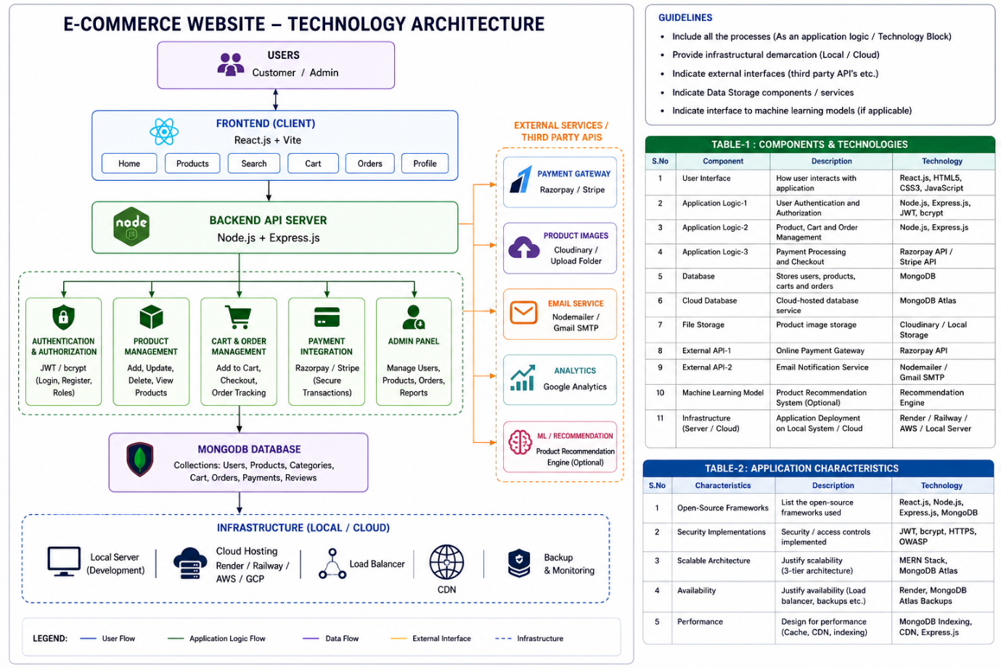

References
- https://c4model.com/
- https://www.ibm.com/cloud/architecture
- https://aws.amazon.com/architecture
- https://developer.ibm.com/patterns/online-order-processing-system-during-pandemic/
- https://medium.com/the-internal-startup/how-to-draw-useful-technical-architecture-diagrams-2d20c9fda90d

